Project Design Phase-II

- Data Flow Diagram & User Stories

Date: 25-10-2026
Team ID: __________________
Project Name: StaffSync – Human Resource Management System
Maximum Marks: 4 Marks

1. Data Flow Diagram (DFD)

A Data Flow Diagram (DFD) illustrates how data moves through the StaffSync application. It shows how the HR administrator interacts with the system, how employee, attendance, and leave information is processed, and how the information is stored in the database.

DFD Level 0 – StaffSync

External Entity: HR Administrator / User

Main Process: StaffSync – Human Resource Management System

Data Stores:

- D1: Employee Database
- D2: Attendance Records
- D3: Leave Requests Database

- Data Flow:

1. The HR administrator provides employee details to StaffSync.
2. StaffSync processes employee information and stores or retrieves employee records.
3. The HR administrator marks attendance, and the system saves attendance records.
4. Users submit leave requests, and the system stores the requests.
5. The HR administrator approves or rejects leave requests, and the system updates their status.
6. StaffSync retrieves the required information from the database and displays it on the dashboard.

- Data flow diagram

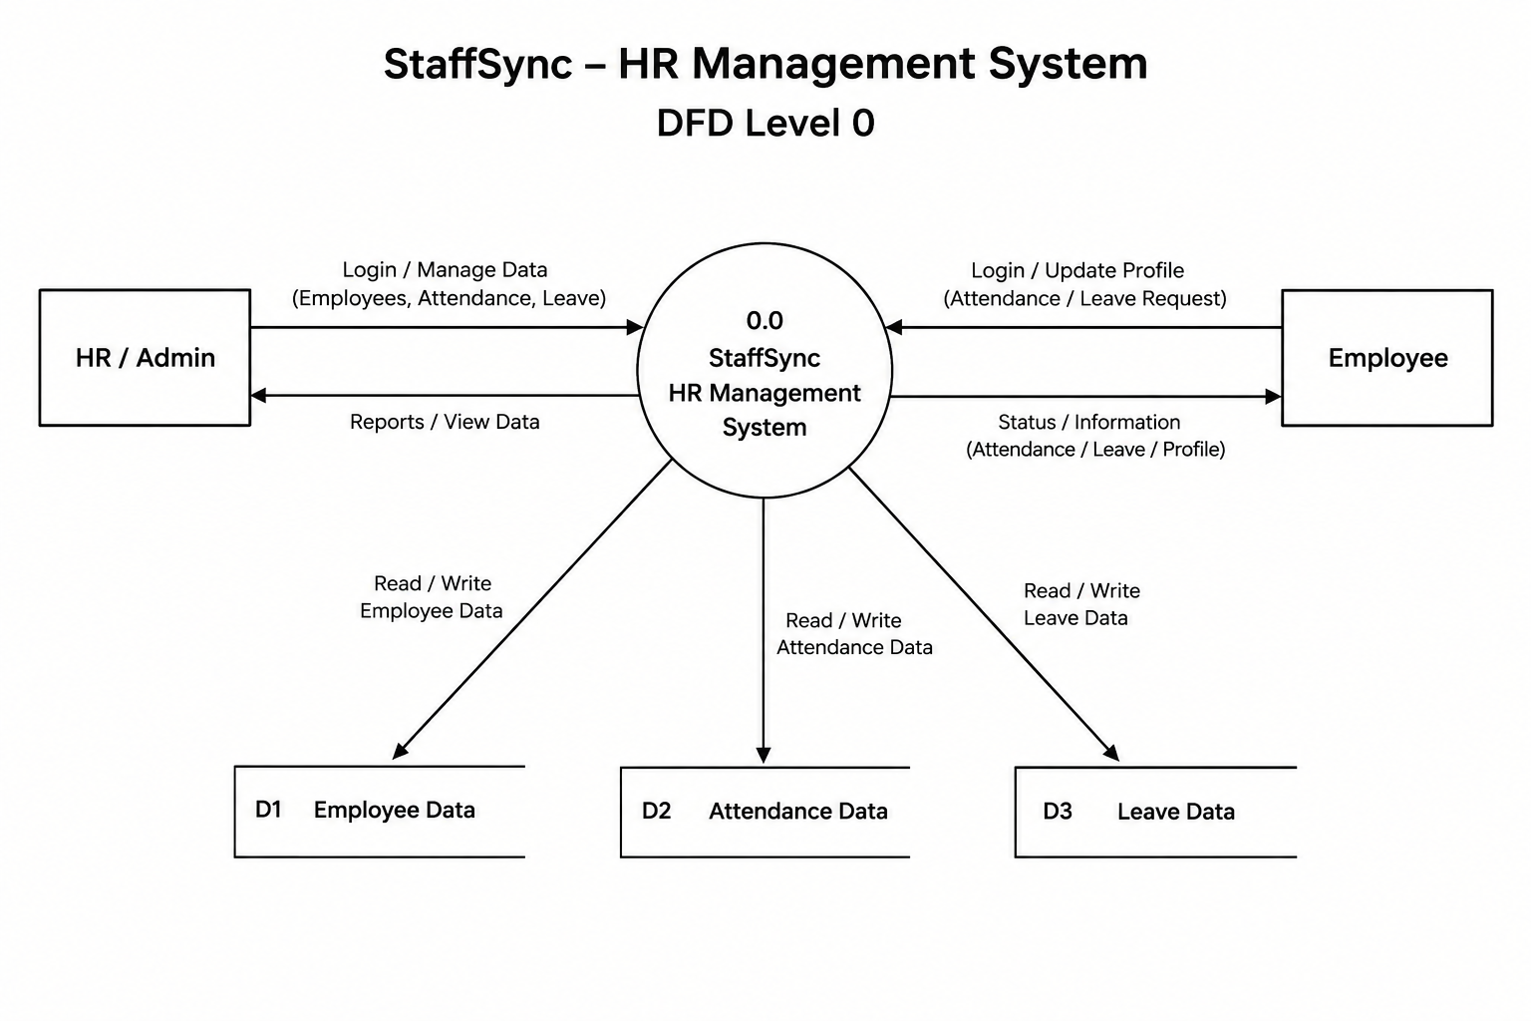

- . User Stories

User stories describe the requirements of StaffSync from the perspective of its users.

User Story Table – StaffSync

User Type| Functional Requirement (Epic)| User Story / Task| Acceptance Criteria| Priority| Release
HR Administrator| Employee Management| As an HR administrator, I want to view employee details so that I can manage employee information easily.| Employee details are displayed correctly.| High| Sprint 1
HR Administrator| Employee Management| As an HR administrator, I want employee records to be stored in the database so that the information can be retrieved later.| Employee records can be retrieved from MongoDB.| High|
Sprint 1
HR Administrator| Attendance Management| As an HR administrator, I want to mark employees as present or absent so that attendance can be tracked.| Attendance status is saved and displayed correctly.| High|

Sprint 2
Employee / User| Leave Management| As a user, I want to submit a leave request so that my leave can be considered.| The leave request is saved and can be viewed.| High| Sprint 3
HR Administrator| Leave Approval| As an HR administrator, I want to approve or reject leave requests so that leave decisions can be recorded.| The leave status is updated after the decision.| High|
Sprint 3
HR Administrator| Dashboard| As an HR administrator, I want to view employee information on a dashboard so that I can access key information easily.| The dashboard displays available employee information.| Medium| Sprint 4

3. Conclusion

The DFD explains the flow of employee, attendance, and leave data within StaffSync. The user stories define the system's main requirements and provide acceptance criteria for testing. These requirements help organize development and improve the usability and reliability of the application.

